**2.(Hollow Rectangle)**

**Exercise**

* **Print the pattern using for loop**



**Approach:**

**So here we did like this**

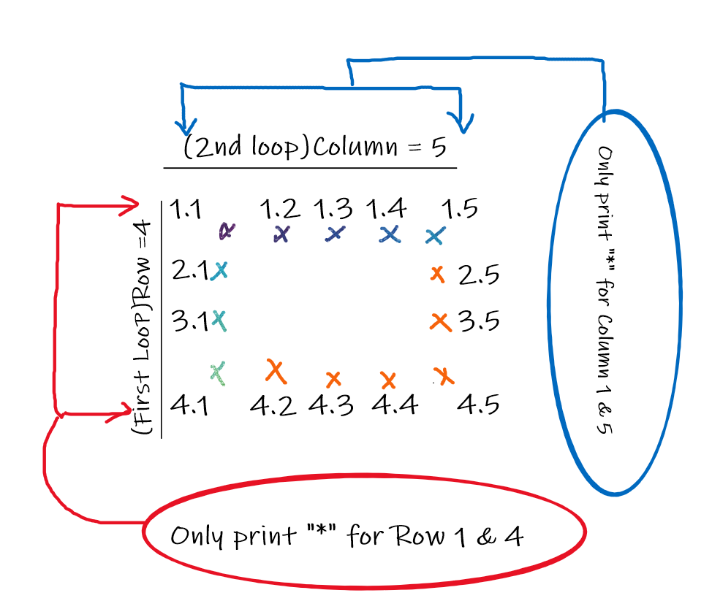

**Solution 👇**

**Java :**

**public class code_xam {**

**public static void main(String[] args) {**

**for(int i=1; i<=4; i++) {**

**for(int j=1; j<=5; j++) {**

**if(i == 1 || i == 4 || j == 1 || j == 5) {**

**System.out.print("*");**

**} else {**

**System.out.print(" ");**

**}**

**}**

**System.out.println();**

**}**

**}**

**}**

**output:**

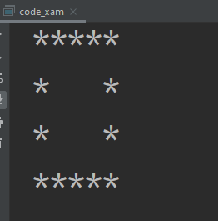

**Python :**

**for i in range(1, 5):**

**for j in range(1, 6):**

**if (i == 1 or i == 4 or**

**j == 1 or j == 5):**

**print("*", end=" ")**

**else:**

**print(" ", end=" ")**

**print()**

**output:**

